Justin Korwin
ENC3241
September 28, 2025
How to Make a Jimmy John’s Sandwich Start to Finish
Audience Analysis
This is a written-out procedure of how to make a Jimmy John’s sandwich. This is for new employees that are in training at Jimmy John’s. By the end of this, any new employee will have the necessary knowledge to take an order, make the sandwich, and put a smile on a customer’s face. You are expected to already have a general knowledge of the menu by the time you are trained to make a whole sandwich start to finish. You are also expected to have watched all training videos including the food safety video as part of the Jimmy John’s onboarding procedure. Remember all sandwiches come with mayo, lettuce and tomato unless otherwise specified by customer or very few of the menu sandwiches.
You will be on the makeline at a Jimmy John’s location to perform these tasks. There can be plenty of distractions when making a sandwich such as other coworkers, guests eating in the dining area, the music playing in the restaurant or even noisy traffic outside of the restaurant. Remember to remain focused on the task at hand such as having your full attention on the customer when taking the order or maintaining focus on the sandwich when building it. This is important to ensure the highest quality customer experience while maintaining food safety standards.
Step 1: Take the Order
- Greet the customer.
When a customer walks into Jimmy John’s, greet them with a warm welcome and a smile.
- Ask for their order.
Politely ask the customer what they would like.
  - On the register screen:
    - Sandwich options are on the left.
    - Modifications are on the right.
    - Combos and miscellaneous items are near the bottom.
    - Categories are at the very bottom

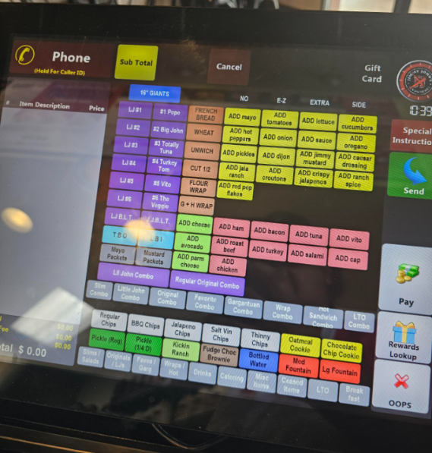
- Enter the order into the register.
For example, if a customer says:
“I would like a Turkey Tom with provolone cheese, light mayo, and add hot peppers,” do the following:
  - Press #4 Turkey Tom.
  - Press ADD cheese.
  - Press E-Z mayo.
  - Press ADD hot peppers.
  - Press Pay, then select either Card or Authorize Card to accept payment.
- Print the ticket.
Once the ticket prints, you are ready to make the sandwich.

Step 2: Make the Sandwich
- Put on gloves.
Always wear gloves before handling food.
- Prepare the bread.
  - Take a 16-inch loaf and cut it in half to make one 8-inch sandwich. Save the other half for the next customer.
  - Slice the bread lengthwise about ¼ inch from the bottom, leaving the spine (hinge) intact.
  - Remove the “guts” (inside bread) from the top half while leaving the outer shell intact.
  - The bread should now look like this:
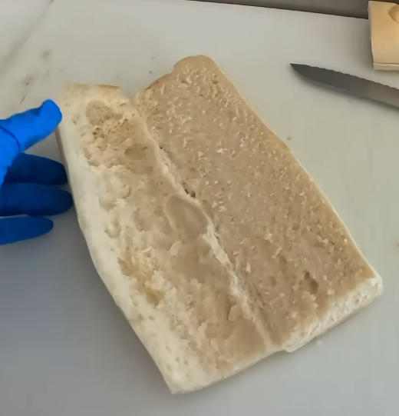

- Spread the mayo.
  - For light mayo, use one level scoop.
  - Spread evenly across the bread with the mayo spatula.
  - Ensure there are no dry spots.
- Add the vegetables.
  - Add vegetables to the bottom half of bread in this order if on sandwich: Tomatoes → Cucumbers → Pickles.
  - Add vegetables to top half of bread in this order if on sandwich: Hot peppers → Onions → Lettuce.
  - Example (Turkey Tom with added hot peppers):
    - 3–4 slices of tomato on the bottom.
    - 6–8 slices of hot peppers on top.
    - Enough shredded lettuce to fill the gutted space.
- Add the turkey and cheese.
  - Take a portion of provolone cheese and place a portion of turkey on top of it.
  - Flip both into the sandwich with the cheese facing upward.
  - Fold the sandwich closed.
  - The finished sandwich should now look like this:
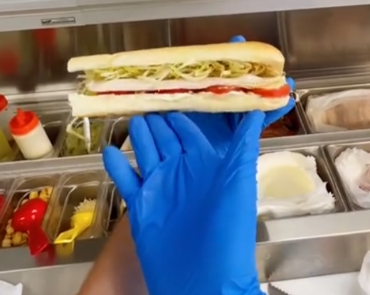
Step 3: Wrap the Sandwich
- Place the sandwich on parchment paper.
  - Lay the sandwich about 1/3rd from the bottom of the paper.
  - Position it so that the sides point toward two opposite corners.
- Wrap the sandwich tightly.
  - Hold the sandwich with one hand.
  - Pull the bottom corner of the parchment over the sandwich and tuck it underneath.
  - Fold in the sides so minimal paper extends past the edges.
  - Roll the sandwich until the top corner meets the rest of the paper.
  - Secure with a Jimmy John’s sticker.
  - The wrapped sandwich should look like this:
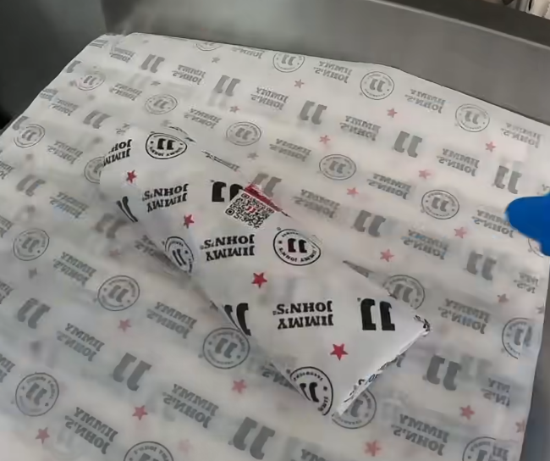
- Complete the order.
  - Call out the sandwich name (e.g., “Turkey Tom”).
  - Hand it to the customer with a smile.
  - Say: “Have a nice day and enjoy your sandwich!”
  - You are now ready for the next order.

